
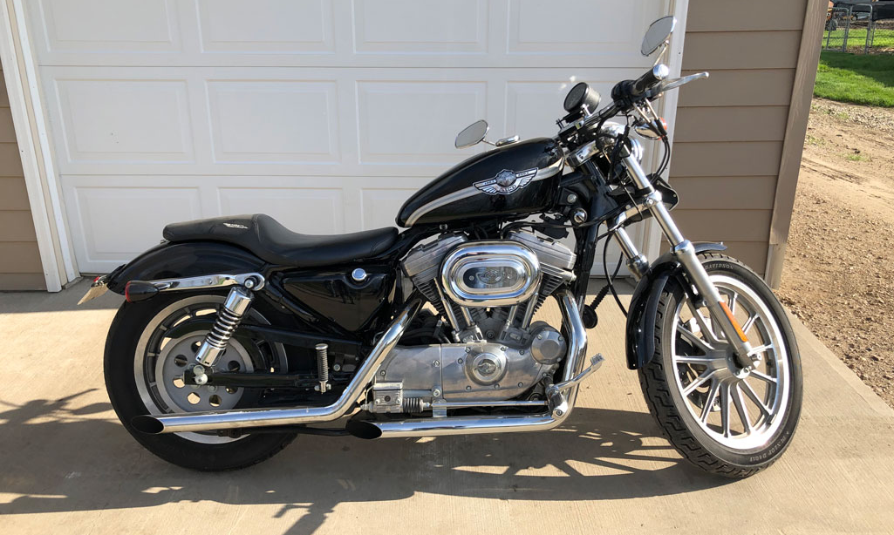
Carol Reinesch & Family– Owners
Phone: (605) 249-2362
Sale Conducted by: Haines Auction Company
Complete listing can be found at www.hainesauctions.com or by contacting
Wayne W. Haines - Phone: 605-680-0612 - Email: hai9@midstatesd.net
Antiques & Collectibles
secretary desk, trunks, sewing machine,
Tonka toys and other metal toys, wood chairs,
wood sled w/metal runners, flat iron and stand, kerosene lamp, lemon squeezer, wood dresser,
wood cupboard, cast iron skillet,
lots of 33 rpm records, souvenir memorabilia,
1903 standard dictionary, 2 iron head boards,
baby carrier, 2 large crocheted tablecloths, clarinet

Yard & Shop Items
Snapper riding mower, shovels, hand tools,
lots of tools- hand and electric, electrical supplies, wiring material, electrician tools, exercise equipment, wood flower pots, hoses, cords, wrenches, rakes,
brand-new pickup tool box, 2 electric table saws

Sunday July 28th, 1:30 pm
4 blocks East of F & M Bank, White Lake SD 402 E 1st St (Roby Street)
Auctioneer’s Note: After nearly 80 years in her home, Carol is moving. She has made a career of cleaning and caring for other people. All items in very excellent condition!

Furniture & Household Items
full size bed w/ like new mattress and box spring,
head and foot board dressers, dresser w/mirror and chest of drawers, computer desk and other desks, wooden bed frame, trunks, blankets and afghans
dining room set- table w/ 5 chairs, coffee table,
5 leather kitchen chairs, electric lift chair,
several recliners, Wurlitzer piano, end tables, book shelves, metal storage cabinets, 2 TV chairs, 4 drawer file cabinet- several small file cabinets, suitcases, holiday decorations, sheets

Appliances & Kitchenware
3 Freezers, (2 chest-1 like new) and 1 upright,
new Kirby Vacuum, window air conditioner, televisions, fans, variety of lamps, meat slicer,
electric fireplace, 42” ceiling fan -new, dehumidifier, microwave oven, toaster oven, iron, large Hamilton Beach mixer, electric griddle, kitchen dishes,
large George Foreman grill, dorm size refrigerator, 30 cup coffee maker, several Corningware pans w/lids,
waffle iron, deep fat fryer, decorative dishes
8-wheel baby stroller, high chair, pictures, crock pots,
knick-knacks, books, toys, dolls and puzzles,
pots and pans, cookbooks, 3 sewing machines,
cake decorating pans (many kid’s shapes)

AUCTION

AUCTION

Other items too numerous to mention…

2003 Harley Davidson Sportster 883cc 6,700 miles new tires in excellent condition

